GEOG 486 Syllabus - Cartography and Visualization

Instructors
Marcela Suarez, PhD.  Assistant Teaching Professor  Department of Geography  Dutton e-Education Institute  College of Earth and Mineral Sciences  marcela.suarez@psu.edu | Fritz Kessler, PhD.  Teaching Professor  Department of Geography  Dutton e-Education Institute  College of Earth and Mineral Sciences  fritz.kessler@psu.edu | Harrison Cole, PhD  Adjunct Teaching Professor  Department of Geography  Dutton e-Education Institute  College of Earth and Mineral Sciences  harrisoncole@psu.edu
Consultation meetings: online via Zoom, by appointment
Contacting your instructor: I encourage you post questions about each assignment to the current week's discussion forum. If you have a question, it is likely that others in the class do too. Asking questions through the forums benefits all students, like raising your hand in a traditional classroom setting. For questions which are more personal in nature, please contact me through the course e-mail system in Canvas.
NOTE: Students are welcome to contact me via e-mail at any time; I will do my best to respond within 24 hours.

Course Overview

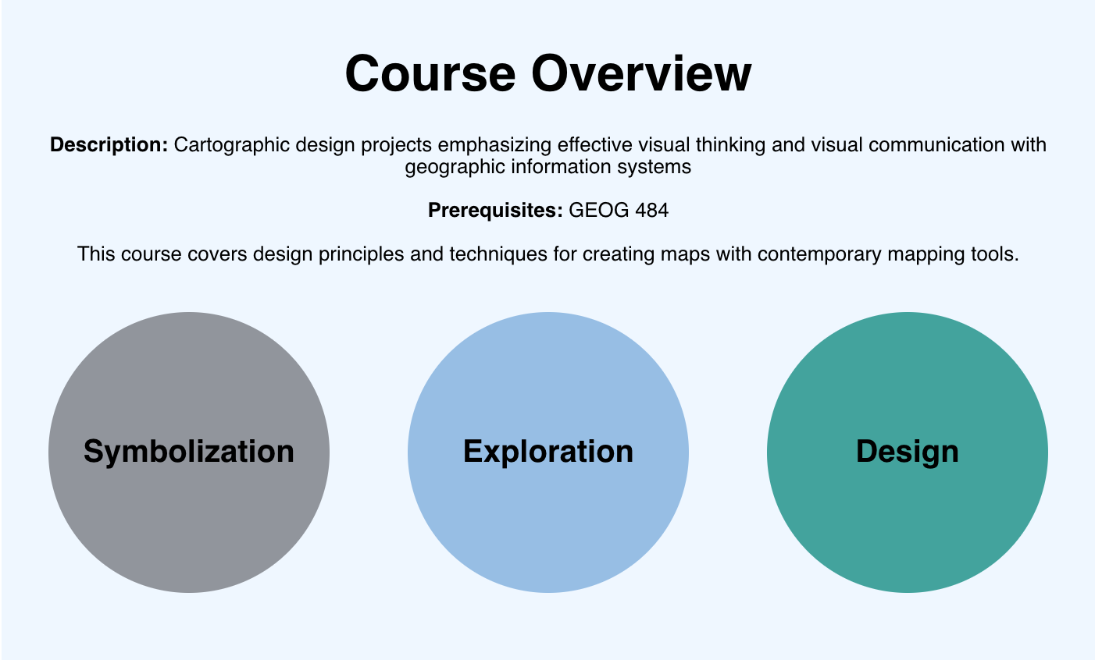

GEOG 486 is a required course in the Master of Science in Spatial Data Science degree program; one of several courses students may choose as their final course in the Certificate Program in Geographic Information System; and an elective for students in the Penn State Master of GIS degree program. This course covers design principles and techniques for creating maps with contemporary mapping tools, including ArcGIS Pro and Tableau. Students will apply cartographic theory to practical problems, with a focus on making optimal design decisions during tasks such as selecting visual variables, classifying and generalizing data, applying principles of color and contrast, and choosing projections for maps. Students will also be introduced to future-focused application topics such as augmented and virtual reality, mapping with multivariate glyphs, the visual depiction of uncertainty, interactive geovisualization and (geo)visual analytics, and decision-making with maps and mapping products.

To fulfill course and educational objectives, students will participate in 9 lessons, each of which will culminate in an assignment that demonstrates mastery of the lessons and their content. Lessons will be supported by readings, quizzes, discussions, and peer critiques. Successful completion of this course will signify mastery in map production for communication and research; students will be practiced in making, analyzing, critiquing, and sharing high-quality maps.

Expectations
This course requires a minimum of 8-12 hours of student activity per week. Your workload may vary depending on your prior experience with the topics and software that we will cover. As in a face-to-face college class, how much and how well you learn is ultimately up to you. You will succeed if you are diligent about keeping up with the class schedule, and if you take advantage of opportunities to engage both your classmates and instructor throughout the course.

Course Goals and Outcomes
At the successful completion of this course, you will be able to:
- create professional and aesthetically pleasing maps through thoughtful application of cartographic conventions;
- select and combine appropriate visual variables to clearly represent geospatial data and communicate map content;
- classify and generalize data, apply principles of color and contrast, and choose projections and scales for maps of varying purpose;
- discuss current trends in cartographic science & technology, including virtual reality, open-source web tools, and geovisual analytics;
- demonstrate mastery in map production for communication and research; analyze, critique, and share high-quality maps.
Specific learning objectives for each lesson are detailed within each module. The class schedule is published on the Canvas Calendar.

Required Course Materials
All materials needed for this course are presented online through our Course website and in Canvas. To access these materials, you need to have an active Penn State Access Account user ID and password (used to access the online course resources). If you have any questions about obtaining or activating your Penn State Access Account and are a World Campus student, please contact the Outreach Helpdesk. If you are a resident education student, please contact the ITS Help Desk.

In addition, you will need the following software:
- ArcGIS Pro 3.x
For this course, you will need to have an up-to-date, educational license of Esri’s ArcGIS Pro software installed on your personal computer. If you don’t already own this software, you may acquire it at no cost to you. See our program’s FAQ for complete ordering instructions. If you have questions regarding the software purchase, please contact the instructor.

Important Note: ArcGIS Pro is a commercial software package that is restricted to personal use by the student. It is unlawful for anyone to use this software package without the appropriate commercial license from Esri Inc. to generate personal or corporate profit or revenue.

Assignments and Grading
- Labs (70% of course grade) Labs apply cartographic design knowledge from each week’s lesson into the making of a map or maps. Assignments are based on practical mapping applications, including trail run mapping and building map-based scientific communication documents and advertisements. The final lab spans two weeks and is an opportunity for students to develop a creative interactive map product worthy of inclusion in a personal portfolio. Labs compose the majority of the course grade in GEOG 486.
- Quizzes (16% of course grade) Most weeks include an online quiz, used to assess student engagement with the week’s readings. Quiz questions are drawn from required course readings and relate directly to lesson and lab objectives. There are a total of 8 quizzes.
- Map Critiques (10% of course grade) Students will participate in short critiques of external and peer-designed maps. Exposure to other students’ maps will provide new design ideas and perspectives, and the reception of thoughtful critique by others will encourage analytical reflection by each student on their own design decisions. There are four critique assignments in the course.
- Discussion Participation (4% of course grade) Participation points will be awarded at the end of the course based on the quality and quantity of each student’s participation in discussion forums. Engagement in every discussion is not required but you need to participate in at least four (4) discussion forums; all students are potentially eligible for full participation credit given they provide regular, respectful contributions.

Grading Scale

Letter grades will be based on the following percentages (percentages refer to the proportion of all possible points earned by the student).

A 90-100

A- 87.5-89.9%

B+ 85-87.4%

B 80-84.9%

B- 77.5-79.9%

C+ 75-77.4%

C 70-74.9%

D 60-69.9%

F <60%

X Unsatisfactory (student did not participate)
Late Assignments: There is a 10% per day late penalty applied to any assignments that are not submitted on time.

Course Schedule
Below you will find a summary of the lessons for this course. Assignment information will be located on each lesson’s checklist. Check the Canvas calendar for all due dates. This course is 10 weeks in length. Except for Lesson 9 (divided into two parts), each lesson is a single entity. Beginning with the course orientation week, you will have two weeks to work on each lesson. Each lesson opens on a Wednesday and is due Tuesday night at 11:59 p.m. Eastern Standard Time Zone to complete the associated work and deliverables. Again, the 11:59 p.m. submission time for all assignments is according to Eastern Standard Time.

While not called out as a deliverable, to be successful in this class, students are expected to read all online course content and associated links as well as assigned external readings in addition to completing the deliverables described below.

Orientation: Welcome to GEOG 486!
Deliverables: | - Complete Orientation Tasks

Lesson 1: Basemaps and Big Picture Design
Deliverables: | - Read all course content and assigned external readings  - Finish up all Orientation requirements  - Submit Lesson 1 Quiz  - Complete Lab 1  - Complete Critique #1

Lesson 2: Lettering and Layouts
Deliverables: | - Read all course content and assigned external readings  - Submit Lesson 2 Quiz  - Complete Lab 2  - Contribute to class discussion

Lesson 3: From Data to Design
Deliverables: | - Read all course content and assigned external readings  - Submit Lesson 3 Quiz  - Complete Lab 3  - Complete Critique #2  - Contribute to class discussion

Lesson 4: Color and Choropleth Maps
Deliverables: | - Read all course content and assigned external readings  - Submit Lesson 4 Quiz  - Complete Lab 4  - Contribute to class discussion

Lesson 5: Flow Mapping and Projections
Deliverables: | - Read all course content and assigned external readings  - Submit Lesson 5 Quiz  - Complete Lab 5  - Complete Critique #3  - Contribute to class discussion

Lesson 6: Terrain Visualization
Deliverables: | - Read all course content and assigned external readings  - Submit Lesson 6 Quiz  - Complete Lab 6  - Contribute to class discussion

Lesson 7: Multivariate and Uncertainty Visualization
Deliverables: | - Read all course content and assigned external readings  - Submit Lesson 7 Quiz  - Complete Lab 7  - Complete Critique #4  - Contribute to class discussion

Lesson 8: Multiscale Web Mapping
Deliverables: | - Read all course content and assigned external readings  - Submit Lesson 8 Quiz  - Complete Lab 8  - Contribute to class discussion

Lesson 9: Beyond the Map (Two Weeks)
Deliverables: | - Read all course content and assigned external readings  - Complete Lab 9  - Contribute to class discussion

Course Policies

Don’t Tempt Fate!

Technology only fails you when you need it most. Waiting until the very last minute to submit something invites technical issues that cost you a late penalty. Part of your responsibility in this class to ensure that your work is received in Canvas by the prescribed deadline (not simply that it’s done by then).

Late Policy
You are expected to submit all of your work on time, as scheduled; however, any late completion is possible if arranged beforehand (e.g., a documented illness or emergency). If you find yourself falling behind, then please reach out to the instructor *before* you miss a deadline, not after. Instructors are people too, and we understand that life happens. Late submissions of any kind incur a10% per day penalty unless approved by the instructor. Assignments will not be accepted after four days.

Technical Requirements
For this course, we recommend the minimum technical requirements outlined on the World Campus Technical Requirements page, including the requirements listed for same-time, synchronous communications. If you need technical assistance at any point during the course, please contact the Outreach Helpdesk (for World Campus students) or the ITS Help Desk (for students at all other campus locations).

Internet Connection
Access to a reliable broadband Internet connection is required for this course. A problem with your Internet access may not be used as an excuse for late, missing, or incomplete coursework. If you experience problems with your Internet connection while working on this course, it is your responsibility to find an alternative Internet access point, such as a public library or wireless hotspot.

Mixed Content
This site is considered a secure website which means that your connection is encrypted. We do, however, link to content that isn’t necessarily encrypted. This is called mixed content. By default, mixed content is blocked in Microsoft’s Edge, Firefox and Chrome. This may result in a blank page or a message saying that only secure content is displayed. Follow the directions on our technical requirements page of the course orientation to view the mixed content.

Penn State Email Accounts
All official communications from the Penn State World Campus are sent to students’ Penn State email accounts. Be sure to check your Penn State account regularly so you don’t miss any important information.

Academic Integrity
This course follows the guidelines for academic integrity of Penn State's College of Earth and Mineral Sciences. Penn State defines academic integrity as “the pursuit of scholarly activity in an open, honest and responsible manner.” Academic integrity includes “a commitment not to engage in or tolerate acts of falsification, misrepresentation, or deception.” In particular, the University defines plagiarism as “the fabrication of information and citations; submitting others’ work from professional journals, books, articles, and papers; submission of other students’ papers, lab results or project reports and representing the work as one’s own.” Penalties for violations of academic integrity may include course failure. To learn more, see Penn State’s “Plagiarism Tutorial for Students.”

Course Copyright
All course materials students receive or to which students have online access are protected by copyright laws. Students may use course materials and make copies for their own use as needed, but unauthorized distribution and/or uploading of materials without the instructor’s express permission is strictly prohibited. University Policy AD 40, the University Policy for the Recording of Classroom Activities and Note Taking Services addresses this issue. Students who engage in the unauthorized distribution of copyrighted materials may be held in violation of the University’s Code of Conduct, and/or liable under Federal and State laws.

Accommodations for Students with Disabilities
Penn State welcomes students with disabilities into the University’s educational programs. Every Penn State campus has an office for students with disabilities. The Student Disability Resources (SDR) website provides contact information for every Penn State campus: Contacts for Disability Resources at all Penn State Campuses. For further information, please visit the Student Disability Resources (SDR) website.
In order to receive consideration for reasonable accommodations, you must contact the appropriate disability services office at the campus where you are officially enrolled, participate in an intake interview, and provide documentation. If the documentation supports your request for reasonable accommodations, your campus’s disability services office will provide you with an accommodation letter. Please share this letter with your instructors and discuss the accommodations with them as early in your courses as possible. You must follow this process for every semester that you request accommodations.

Military Personnel
Veterans and currently serving military personnel and/or spouses with unique circumstances (e.g., upcoming deployments, drill/duty requirements, disabilities, VA appointments, etc.) are welcome and encouraged to communicate these, in advance if possible, to the instructor in the case that special arrangements need to be made.

Change in Normal Campus Operations
In case of weather-related delays at the University, this online course will proceed as planned. Your instructor will inform you if there are any extenuating circumstances regarding content or activity due dates in the course due to weather delays. If you are affected by a weather-related emergency, please contact your instructor at the earliest possible time to make special arrangements.

Connect Online with Caution
Penn State is committed to educational access for all. Our students come from all walks of life and have diverse life experiences. As with any other online community, the lack of physical interaction in an online classroom can create a false sense of anonymity and security. While one can make new friends online, digital relationships can also be misleading. Good judgment and decision making are critical when choosing to disclose personal information with others whom you do not know.

Reporting Educational Equity Concerns
Penn State takes great pride to foster a diverse and inclusive environment for students, faculty, and staff. Acts of intolerance, discrimination, or harassment due to age, ancestry, color, disability, gender, gender identity, national origin, race, religious belief, sexual orientation, or veteran status are not tolerated (https://policy.psu.edu/policies/ad29) and can be reported through Educational Equity via the Report Bias webpage.

Counseling and Psychological Services
Many students at Penn State face personal challenges or have psychological needs that may interfere with their academic progress, social development, or emotional wellbeing. The university offers a variety of confidential services to help you through difficult times, including individual and group counseling, crisis intervention, consultations, online chats, and mental health screenings. These services are provided by staff who welcome all students and embrace a philosophy respectful of clients’ cultural and religious backgrounds, and sensitive to differences in race, ability, gender identity and sexual orientation. Services include the following:
- Counseling and Psychological Services at University Park (CAPS): 814-863-0395
- Counseling and Psychological Services at Commonwealth Campuses
- CAPS website
- Penn State Crisis Line (24 hours/7 days/week): 877-229-6400
- Crisis Text Line (24 hours/7 days/week): Text LIONS to 741741
- A newsletter discussing the various resources available through Penn State to help manage stress, balance life with work, etc.

Attendance
This course will be conducted entirely asynchronously online. There will be no set class meeting times, but you will be required to complete assignments with specific due dates. It is your responsibility to complete the work on time, which may require you to complete the work early if you plan to travel or participate in national holidays, religious observances, or University-approved activities.
If you need to request an exception due to a personal or medical emergency, contact the instructor directly as soon as you are able. The instructor's ability to accommodate you is dependent on the earliest possible notification. Such requests will be considered on a case-by-case basis.

Netiquette
The term “Netiquette” refers to the etiquette guidelines for electronic communications, such as email and bulletin board postings. Netiquette covers not only rules to maintain civility in discussions, but also special guidelines unique to the electronic nature of forum messages. Please review some general Netiquette guidelines that should be followed when communicating in this course.

Mandated Reporting Statement
Penn State’s policies require me, as a faculty member, to share information about incidents of sex-based discrimination and harassment (discrimination, harassment, sexual harassment, sexual misconduct, dating violence, domestic violence, stalking, and retaliation) with Penn State’s Title IX coordinator or deputy coordinators, regardless of whether the incidents are stated to me in person or shared by students as part of their coursework. For more information regarding the University’s policies and procedures for responding to reports of sexual or gender-based harassment or misconduct, please visit Penn State's Office of Sexual Misconduct Prevention & Response website.
Additionally, I am required to make a report on any reasonable suspicion of child abuse in accordance with the Pennsylvania Child Protective Services Law.

Diversity, Inclusion, and Respect
Penn State is “committed to creating an educational environment which is free from intolerance directed toward individuals or groups and strives to create and maintain an environment that fosters respect for others” as stated in Policy AD29 Statement on Intolerance. All members of this class are expected to contribute to a respectful, welcoming and inclusive environment and to interact with civility.

For additional information, see:
- Penn State Affirmative Action non-discrimination statement
- Policy AD 85 Sexual and gender-based harassment and misconduct, Title IX
- Policy AD91 Discrimination and Harassment, and Related inappropriate Conduct
- Penn State Statement on Diversity, Equity, and Inclusive Excellence
- Penn State Values
- Penn State Principles
- All In at Penn State: A Commitment to Diversity and Inclusion

Disclaimer
Please note that the specifics of this Course Syllabus can be changed at any time, and you will be responsible for abiding by any such changes. All changes will be communicated with you via email, course announcement and/or course discussion forum.

